**Demander login**

1. In demander dashboard in the stock demand|issue block when clicked in total and approved permission denial is shown and when clicked in pending under maintenance window is shown.

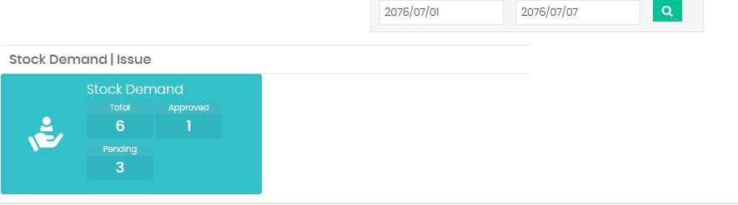

2. In demand request at first in from dropdown at first the list is shown but when clicked in refresh button then the list is not shown preventing from saving the demand form.

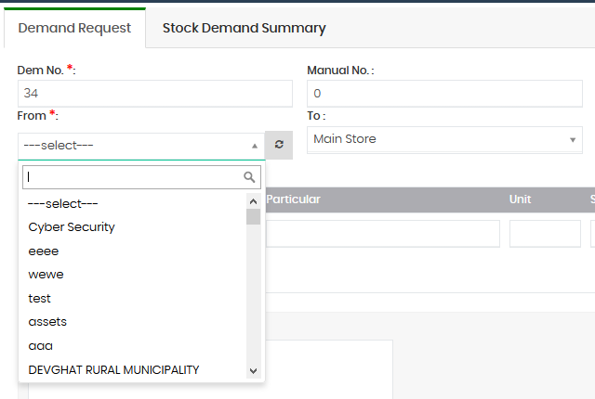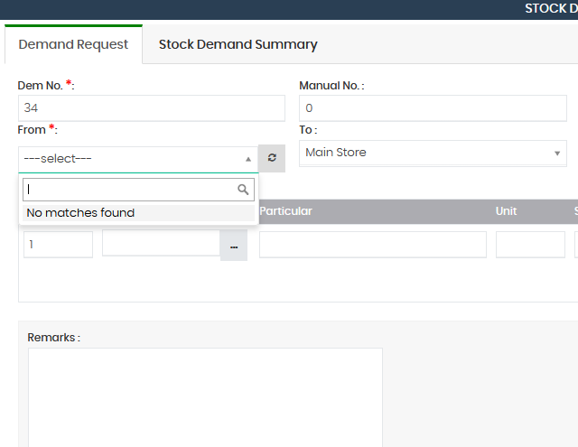

3. Remove available, out of stock and limited label in item search (list of items) in demander user.

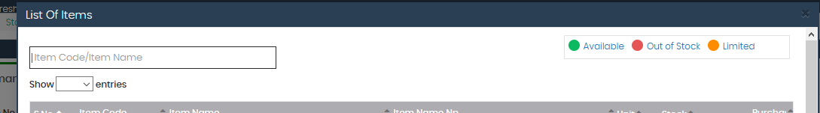

4. In stock demand summary the branch dropdown is not necessary for demander. It should be the default value of the demander's branch when creating the user.

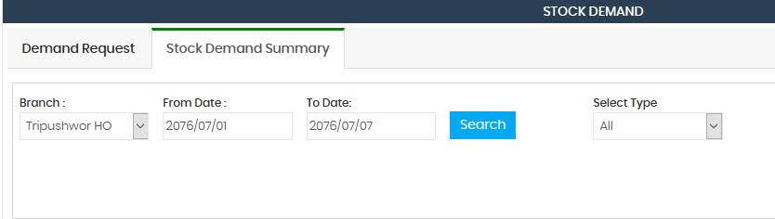

5. Minor CSS issue in action tab.

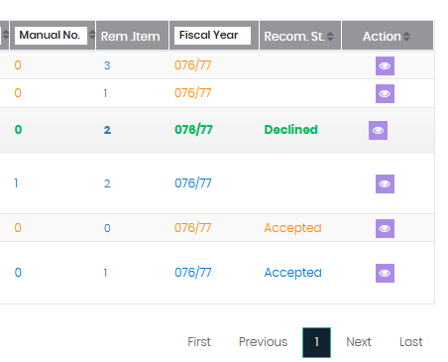

6. Remove estimated cost from this view and issue button also in case of approved status.

